Lurgan Credit Union Easter Competition 2024
Child’s Name:

Child’s Age:

Contact No:

CONSENT TO USE PHOTOGRAPHIC IMAGES
I/we consent to and permit the use of photographic images by Lurgan Credit Union in advertising or publicity materials used to promote the Easter art competition or the outcome of the Easter art competition. I/we understand photographic images may be used for distribution on internal publications/web and social media (e.g. Facebook, Twitter, YouTube and Instagram). For further information please see our privacy notice. If you consent to use of photographic images, you can later withdraw such consent prior to publication by emailing manager@lurgancu.com

Parent/ Guardian signature: ___________________________________________

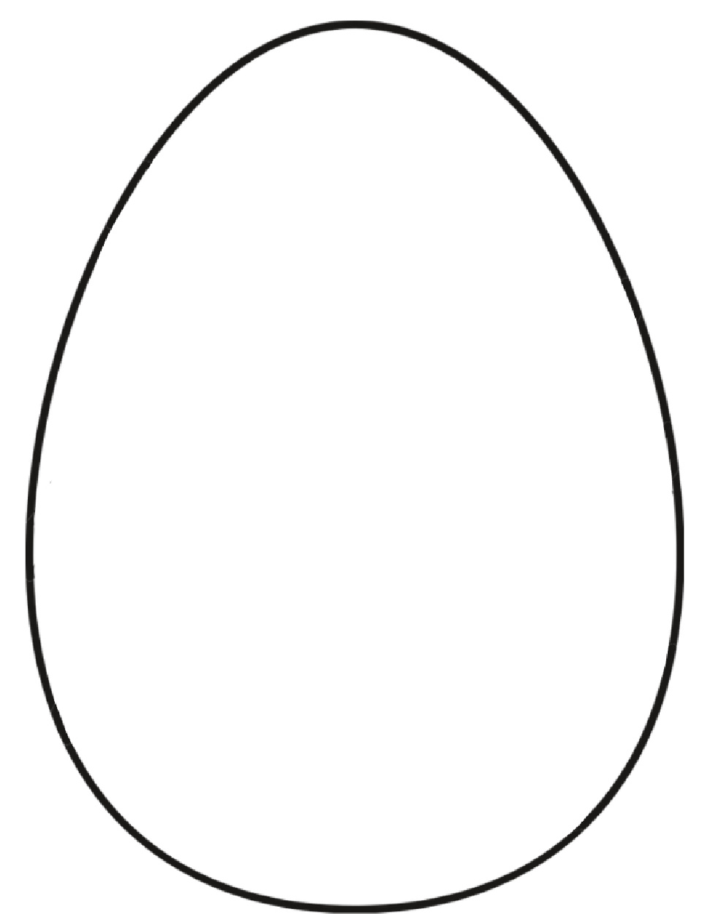
DESIGN YOUR OWN EASTER EGG

